Use-Case Specification: Add Leave

Version 1.0

Revision History

|  |  |  |  |
| --- | --- | --- | --- |
| **Date** | **Version** | **Description** | **Author** |
| 15/12/2019 | 1.0 | Final | Quản Trọng Tú |
|  |  |  |  |
|  |  |  |  |
|  |  |  |  |

Table of Contents

1. Use-Case Name 4

1.1 Brief Description 4

1.2 Actor 4

2. Flow of Events 4

2.1 Basic Flow 4

3. Special Requirements 5

4. Preconditions 5

5. Postconditions 5

6. Extension Points 5

Use-Case Specification: Adding Leave

# Use-Case Name

## Brief Description

This use case defines the steps of adding a Leave for user who are working in company to store it in the database system. Employee can easily add a new leave for each user and themselves.

## Actor

Employee

# Flow of Events

## Basic Flow

The Employee can create the Leave to the Administrator, employee have ability to create a lot of leave and wait for admin update status and processing date. If employee add leave successfully, the application illustrates the message success. Other case, the application will display message fail.

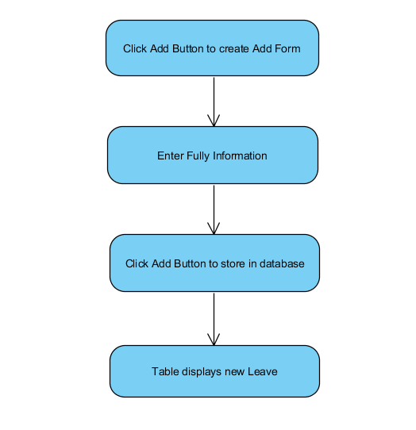

Basic Flow of Adding Leave

# Special Requirements

* Employee has basic knowledge of manipulating the database and know how database inputs successfully.
* Employee need to input correctly constraint.

# Preconditions

* Employee have to login into application and access Manage Leave view.

# Postconditions

The Message was return message if its failure or success.

# Extension Points

The Employee checks the database and application to ensure that the user is added Leave